FAMU - FSU COLLEGE OF ENGINEERING

FPL – Lineman Robot Senior Design Project

Dr. Jerris Hooker

Dr. Shayne McConomy



Concept Selection



*Authors:*

Denis Dineen

Jacob Hutto

Hunter Kramer

Doran McFalls

Nicolas Palmeiro

*Date:*

October 25th, 2019



## Pairwise Comparison

When looking at customer requirements it becomes apparent that not all requirements have equal value when deciding on a concept to implement. For this reason, a pairwise comparison matrix is created in order to compare each customer requirement from one another and decide on which should hold the most value when considering concepts. Table 1 shows a pairwise comparison of all the customer requirements for our project. Each requirement is compared to another an assigned a ‘0’ if its less important or a ‘1' if it's more important than the requirement it is being compared too. In the case of Table 1, the results show that “increasing safety” is the most important requirement with a total of 8 points while “while storing data has the least amount of points with a score of ‘1’ showing it is the least important requirement to consider.

*Table 1 - Pairwise Comparison Matrix*

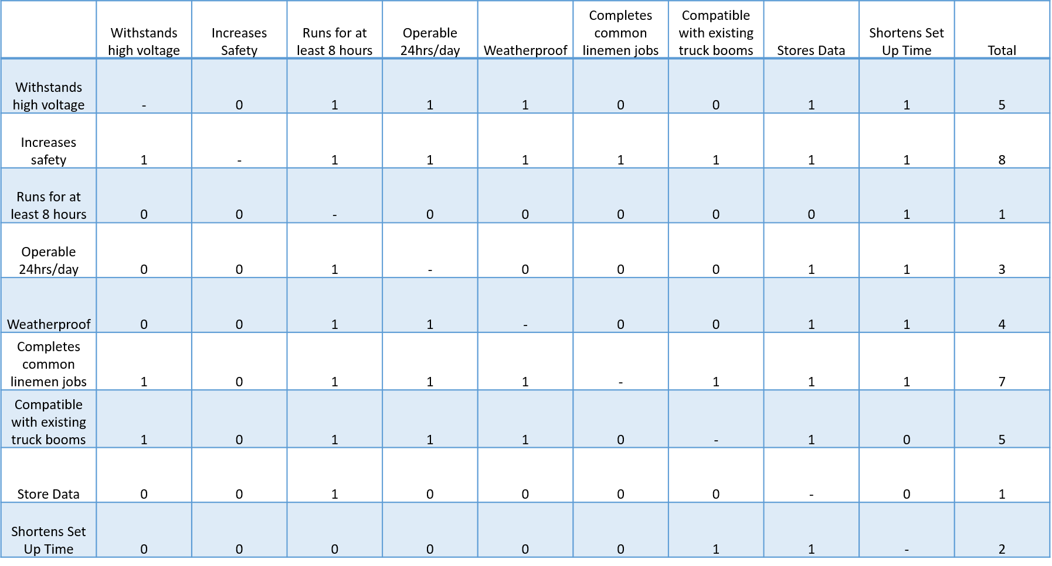

## House of Quality

The house of quality comparison matrix directly relates customer requirements to the engineering characteristics of the solution. For example, one of our customer’s requirements is that “The robot should be able to run for at least 8 hours” this directly correlates to the engineering characteristic of “total runtime” which is a quality of our robot that can be directly measured and quantified. Engineering characteristics that have any correlation to each of the customer’s requirements gets a rating from 1 to 9 based upon the strength of the correlation between the two. These correlation coefficients get multiplied by the importance weight factors determined by the previous pairwise comparison and get summed at the bottom of the matrix. These sums then get normalized by the sum of the weight factors and are ranked from highest to lowest. The highest ranked engineering characteristics are what the team should focus more heavily on since those will be the characteristics that fulfill the most critical customer requirements. For this reason, concepts that successfully meet the highest ranked engineering characteristics will be favored over those that don’t even if they complete more of the lower ranked characteristics.

*Table 2 – Quality Comparison Matrix*

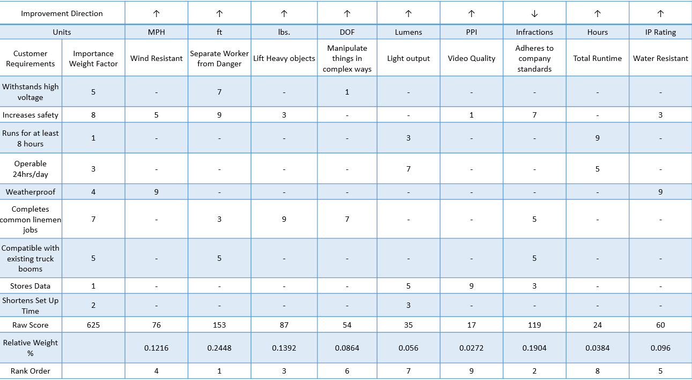

From the table it should be noted that the 3 most important engineering characteristics going forward should be: 1. Distance between worker and Energized Line, 2. Adhering to Company Standards, and 3. Lifting Heavy Objects. These characteristics define the main focus of the project, which is first and foremost safety, and then the ability for companies to use this to complete the day to day tasks of linemen which include lifting objects such as insulators that weigh as much as 35 lbs. Past that, the characteristics that will cause certain concepts to stand out from the others will be their weather resistance and ability to manipulate objects in complex ways.

## Pugh Chart

A Pugh chart was utilized in the next stage of concept selection. This tool takes the concepts developed by the team and directly compares them to several datums in terms of our selection criteria. These criteria are the engineering characteristics deemed most important from our house of quality. The purpose of the Pugh chart is to show where each concept has its strengths and weaknesses and to be able to eliminate concepts that aren’t viable or don’t meet the selection criteria.

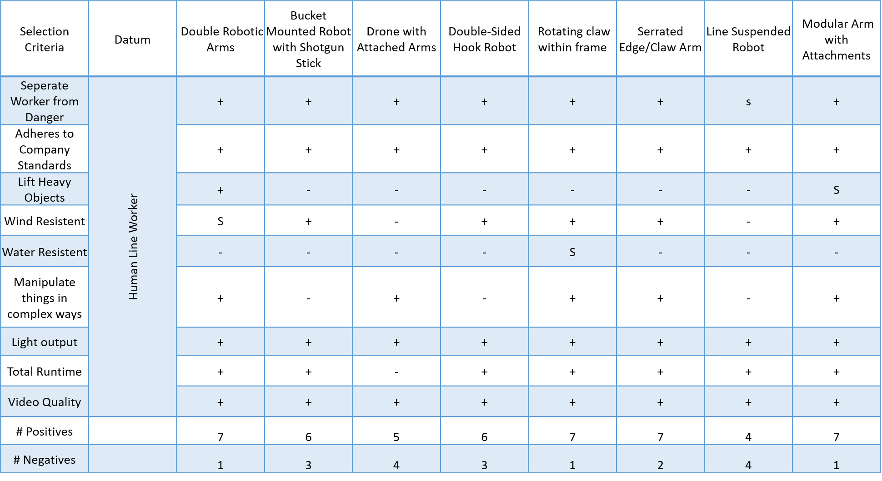*Table 3 – Human Line Worker Pugh Matrix*

The first datum the team chose was a human line worker. We chose this as the first datum because the robot needs to be at least as effective as this datum to be considered a viable concept. In our first iteration of the Pugh chart (shown in Table 3) we eliminated two concepts, the line suspended robot and the drone with arms. Both concepts did not show enough improvement over the datum to be viable solutions. For the next iteration we chose the double robotic arms as our new datum to get a feel for how the concepts compared to each other.

*Table 4 – Double Robotic Arms Pugh Matrix*

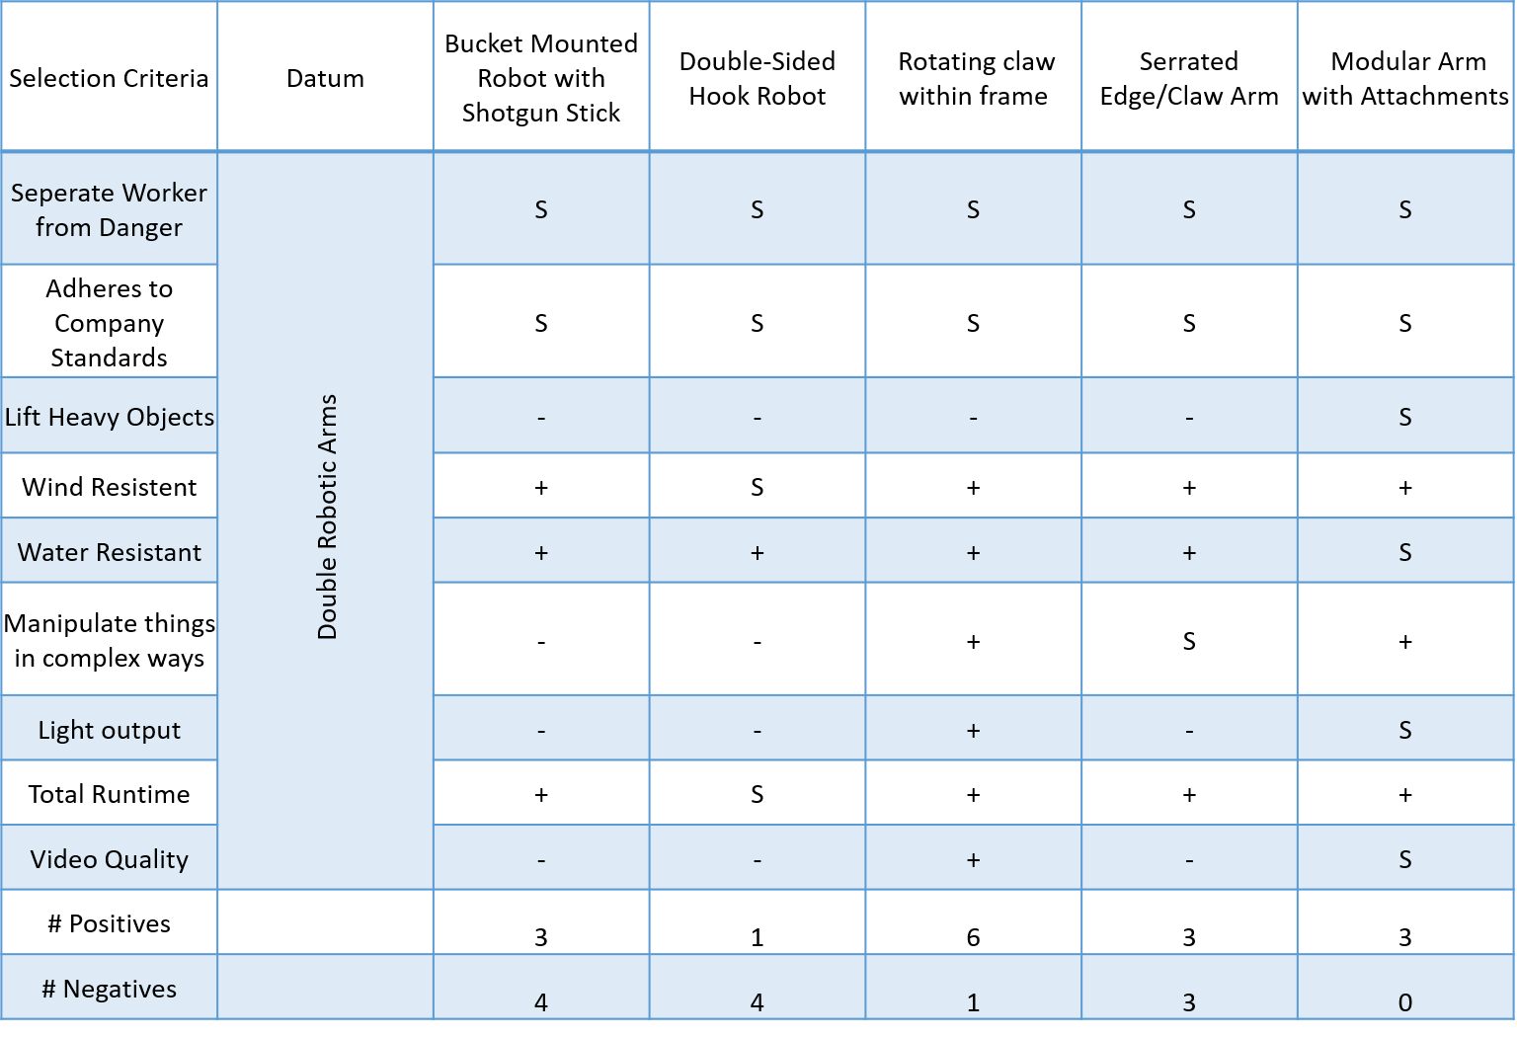

From this Pugh chart (shown in Table 4) we discovered that the bucket mounted robot with shotgun stick and the double-sided hook robot had more weaknesses than strengths and therefore did not meet our expectations. Moving forward the team also dropped the double robotic arms as a concept based on feasibility. It did not seem likely that we would be able to construct, and control two separate arms simultaneously given our time and budget. At the end of this process we eliminated 5 concepts and were left with our 3 best concepts: the rotating claw within frame, the serrated edge/ claw arm, and the modular arm with attachments.

## Analytical Hierarchy Process (AHP)

Following the Pugh charts, a pairwise comparison matrix was created for a set of criteria our team felt was critical to the physical development of the project. Once each criteria weight was established and normalized, the top three concepts were compared to one another for each criterion. These concept-criterion comparison matrices were also normalized to determine the Design Alternative Priorities {Pi} values. Consistency checks and comparisons were also performed to try and reduce the amount of bias among team members during the concept selection process. These calculations are shown in Tables 5-18 below.

*Table 5 – Criteria Comparison Matrix*

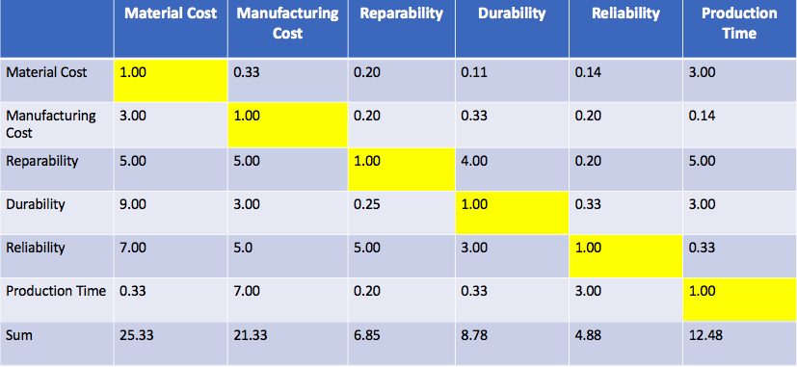

*Table 6 – Normalized Criteria Comparison Matrix*

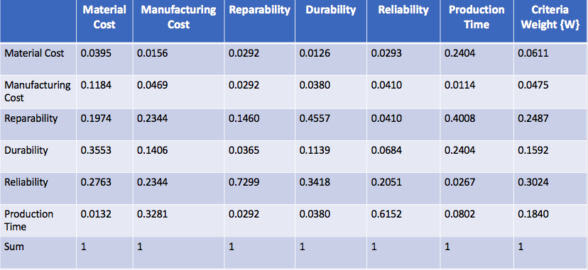

*Table 7 – Material Cost Matrix*

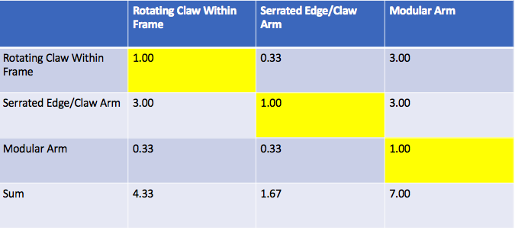

*Table 8 – Normalized Material Cost Matrix*

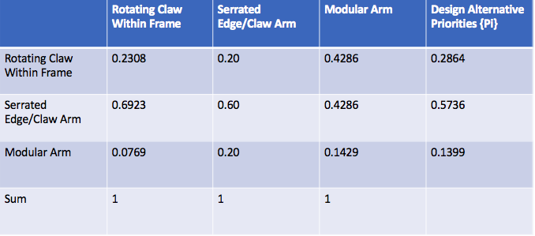

*Table 9 – Manufacturing Cost Matrix*

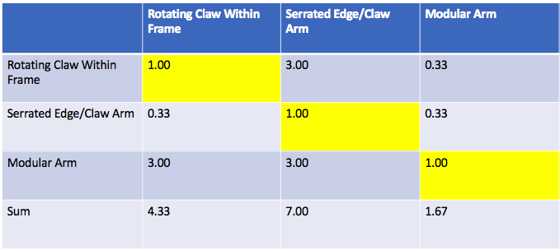

*Table 10 – Normalized Manufacturing Cost Matrix*

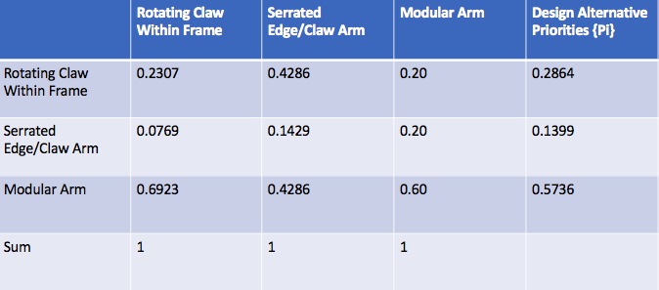

*Table 11 – Reparability Matrix*

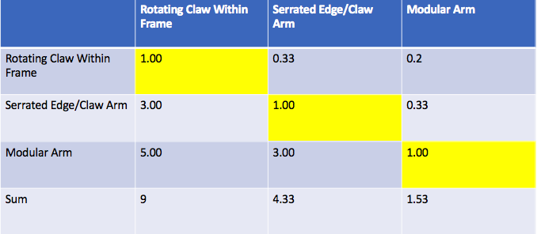

*Table 12 – Normalized Reparability Matrix*

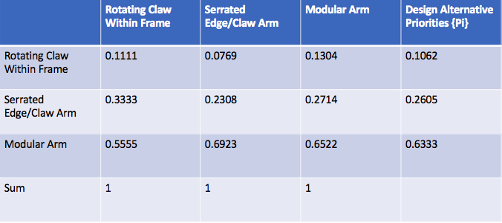

*Table 13 – Durability Matrix*

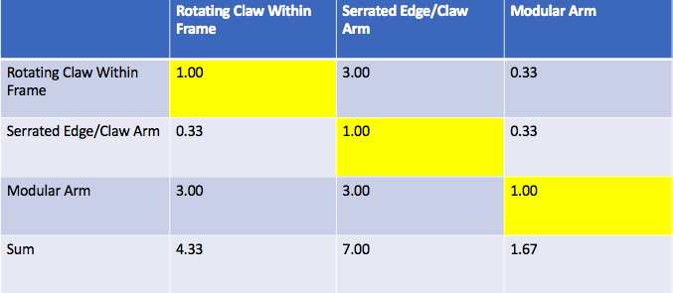

*Table 14 – Normalized Durability Matrix*

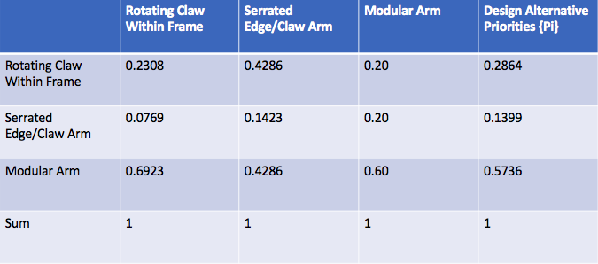

*Table 15 – Reliability Matrix*

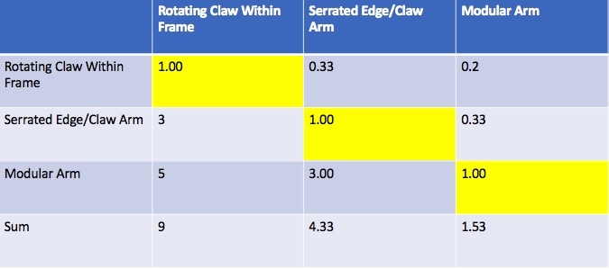

*Table 16 – Normalized Reliability Matrix*

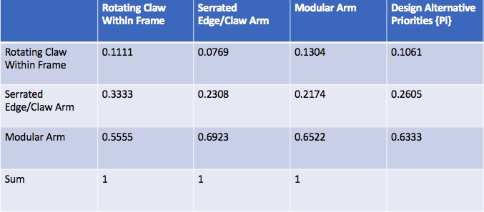

*Table 17 – Production Time Matrix*

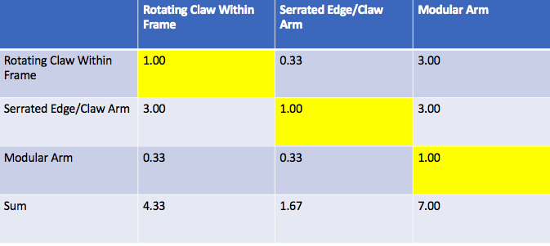

*Table 18 – Normalized Production Time Matrix*

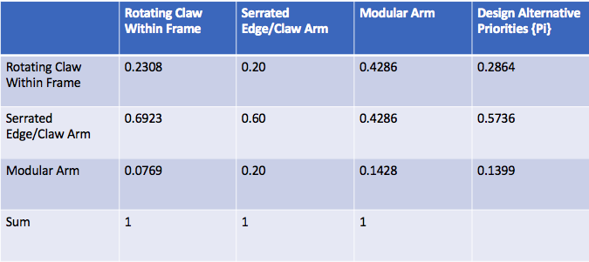

## Final Selection

The final step in the selection process was to determine the Alternative Values [Table 21] of the top three concepts based off their Design Alternative Priorities and Criteria Weights. The numerical values for both categories are located in Tables 19 and 20, respectively. Calculating the sum-product of the matrices allowed our team to determine that the “Modular Arm” was the best solution to bring to the next stage of the design process. However, this does not mean that we will not be able to incorporate aspects of other concepts into the final design and prototypes.

*Table 19 – Final Ratings Matrix (Design Alternative Priorities)*

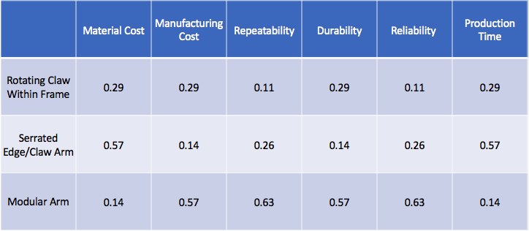

*Table 20 – Final Ratings Matrix (Criteria Weights)*

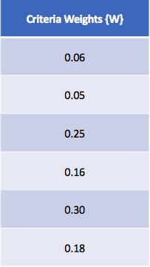

*Table 21 – Final Ratings Matrix (Alternative Values)*

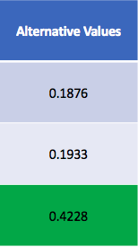

Concept Overview: The modular arm allows the team to begin solving the total problem one task at a time. Different tools can be designed and added as research on the product develops but also allows for a solution to at least a few problems more immediately. The arm itself utilizes a system of channel locks to firmly attach each tool while also making attachment and release of the tools simple. The attachment and removal of each tool could either be done by the user on the ground or automatically by the robot at the line if the tools are located within the bucket. Electrical connections for each attachment will be conveniently located at the end of the arm and on top of each attachment such that when the channel locks are in the fully locked position, power is transmitted to the tool for operation. Each tool could also have an identification code embedded in the top to communicate back to the which tool it is connected to since the control system will need to be modified to work for each individual tool. The benefits of this arm are that the startup cost for this sort of solution would be relatively low as compared to a robotic arm that has full maneuverability since each tool could be added on as money becomes available and that each tool would be finely tuned to complete whatever task is being done.

*Figure 1 – 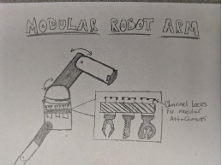Modular Arm Concept Drawing*